**TFTP Specifications:**

1. Port Number: 69 (not kidding)
2. Protocols: UDP and TCP; To be implemented in UDP
3. 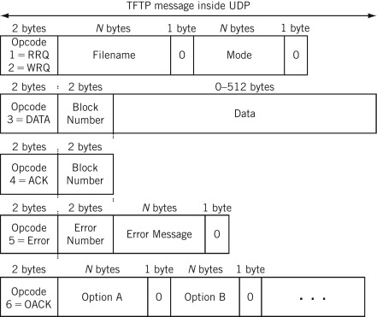
4. RFC 1350
   1. Overview of the protocol
      1. Any transfer begins with a request to read or write a file. This also serves as a request to connection.
      2. When granted by the server, the connection is opened with the file being sent in a fixed length blocks of 512 bytes.
      3. Each data packet contains one block of data and must be acknowledged by an acknowledgement packet before the next packet can be sent.
      4. Any data packet sent with less than 512 bytes signals the termination of a transfer.
      5. While there are different causes of a transmission having errors, there is only one error condition that does not cause termination of the program which is the source port of a received packet being incorrect. If incase this occurs, an error packet is sent back to the originating host.
5. RFC 2347
6. RFC 2348
7. RFC 2349